MBARARA UNIVERSITY OF SCIENCE AND TECHNOLOGY

FACULTY OF COMPUTING AND INFORMATICS

DATABASE MANAGEMENT SYSTEMS
Database Management Systems — Project Report

System Name | Tourism Destination Management System
Group Area | Tourism Management Platform
Database Technology | MySQL 8.0+ Relational Database
Data Context | Uganda Tourism — Real Locations & Authentic Pricing (USD)
Institution | Mbarara University of Science and Technology (MUST)
Course | Database Management Systems (DBMS)
Module Scope | Destinations, Activities, Destination categories, Tourists, Bookings,
Group Member Focus | Destination Module
Academic Year | 2025 / 2026

Executive Summary.
This report presents the complete database design and implementation of the Tourism Destination Management System (TDMS) — Destination Module, developed as part of the group C of Database Management Systems at Mbarara University of Science and Technology. The broader project covers the tourism sector; this module specifically addresses destination management. The system is built on MySQL 8.0 and manages tourism destinations in Uganda — including national parks, lakes, cultural heritage sites, and urban attractions. It enables tourism operators, travel agents, and tourists to browse destinations and discover activities.The database comprises five core entities: DestinationCategory, Destination, Activity, Tourist and Booking. The design follows Third Normal Form (3NF) and includes full referentialintegrity, ENUM-enforced constraints, soft-delete patterns, and UTF-8 multilingual support for local Ugandan language names.

Sample data drawn from Uganda's iconic tourism sites — Bwindi Impenetrable National Park, Murchison Falls, Lake Bunyonyi, Queen Elizabeth National Park, and Kampala — demonstrates real-world applicability.

Business Case
Application Domain
Uganda's tourism sector is a significant contributor to the national economy, attracting visitors to
world-class wildlife destinations including Bwindi's mountain gorillas and Murchison Falls. The Tourism
Destination Management System serves as the central registry and discovery engine for tourism
destinations within the country.
The system serves three primary user groups:
• Tourism Operators & Travel Agents — who need to manage destination listings, and
bookings.
• Tourists (domestic & international) — who browse destinations.
• System Administrators — who maintain data integrity, manage categories, and generate reports.
Supported operations include destination registration and categorization, activity management and pricing, tourist registration and booking processing.

Benefits Analysis
Tangible Benefits:
• Elimination of manual, paper-based booking records reduces data entry errors and retrieval time.
• Centralised destination catalogue enables travel agents to find and quote packages faster.
• Analytical queries provide real-time revenue and occupancy data for business decisions.
• Unique review per tourist-destination pair ensures authentic feedback, improving package quality.

Intangible Benefits:
• Enhanced tourist experience through structured destination information and transparent pricing.
• Preservation of Uganda's cultural tourism data in a multilingual (UTF-8) format.
• Improved coordination between tourism sub-modules (payments, hotels, transport).
• Supports Uganda Tourism Board's digital transformation agenda.

User Issues
• Skill Requirements: Tourism operators need basic computer literacy; SQL queries are abstracted
through a future front-end interface.
• Adoption Effort: Data migration from existing spreadsheets/paper records requires one-time effort
estimated at 2–3 weeks.
• Training: Structured training sessions for travel agents (booking workflow) and admins (database
maintenance).
• Language: UTF-8 support accommodates Luganda, Runyankole, and other local language
destination names.

Design:
List of Entities
The Destination Module consists of seven core entities. Each entity represents a distinct real-world concept;

NO | Entity | Real world concept | Role in system
1 | DestinationCategory | Classification types for example national park | Group destinations for filtering.
2 | Destination | Specific location in Uganda | Central entity for activities.
3 | Activity | Specific offering for example gorilla trekking. | Defines what tourists do at a site.
4 | Tourist | Registered customer. | Primary user making bookings.
5 | Booking | Confirmed reservation | Transaction record linking to destinations.

Entity Attributes
The following tables provide comprehensive attribute definitions for each entity. PK = Primary Key, FK = Foreign Key, UQ = Unique Constraint.

Entity: DestinationCategory
Attribute | Data Type | Constraints | Key | Description
category_id | INT | NOT NULL, AUTO_INCREMENT | PK | Unique identifier for each category
category_name | VARCHAR(100) | NOT NULL |  | Name of the category (e.g. National Park, Lake)
description | TEXT | NULL |  | Detailed description of the category type
parent_category_id | INT | NULL | FK | Links to category_id for sub-categories
is_active | BOOLEAN | DEFAULT TRUE |  | Soft-delete flag to enable/disable category.

Entity: Destination
Attribute | Data Type | Constraints | Key | Description
destination_id | INT | NOT NULL, AUTO_INCREMENT | PK | Unique identifier for the destination
category_id | INT | NOT NULL | FK→DestinationCategory | Category this destination belongs to
destination_name | VARCHAR(150) | NOT NULL, UNIQUE |  | Official name of the site (e.g Murchison falls)
region | VARCHAR(50) | NOT NULL |  | Ugandan region (e.g Western, Northern)
entry_fee_usd | DECIMAL(10,2) | CHECK(fee >=0) |  | Standard entry cost for international visitors.
district | VARCHAR(100) | NOT NULL |  | Administrative district in Uganda

Entity: Activity
Attribute | Data Type | Constraints | Key | Description
activity_id | INT | NOT NULL, AUTO_INCREMENT | PK | Unique identifier for the activity
destination_id | INT | NOT NULL | FK→Destination | Destination where this activity is offered
activity_name | VARCHAR(100) | NOT NULL |  | Name of the activity (e.g. Gorilla Trekking)
activity_type | ENUM(...) | NOT NULL |  | 'Wildlife','Adventure','Cultural','Water','Scenic'
price_per_person | DECIMAL(10,2) | NOT NULL, CHECK ≥ 0 |  | Individual participation fee in USD
difficulty_level | VARCHAR(20) |  |  | Rating 'Easy','Moderate','Challenging',

Entity: Tourist
Attribute | Data Type | Constraints | Key | Description
tourist_id | INT | NOT NULL, AUTO_INCREMENT | PK | Unique identifier for the registered tourist
first_name | VARCHAR(50) | NOT NULL |  | Tourist's first / given name
last_name | VARCHAR(50) | NOT NULL |  | Tourist's family / surname
email | VARCHAR(100) | NOT NULL, UNIQUE | UQ | Email address — used for login and notifications
nationality | VARCHAR(80) | NOT NULL |  | Tourist's country of citizenship
passport_number | VARCHAR(20) | NULL, UNIQUE | UQ | Passport or national ID number
registration_date | DATE | NOT NULL, DEFAULT CURRENT_DATE |  | Date tourist registered in the system

Entity: Booking
Attribute | Data Type | Constraints | Key | Description
booking_id | INT | NOT NULL, AUTO_INCREMENT | PK | Unique booking identifier
tourist_id | INT | NOT NULL | FK→Tourist | Tourist who made this booking
destination_id | INT | NOT NULL | FK→Destination | Links to the Destination visited.
booking_date | DATE | NOT NULL, DEFAULT CURRENT_DATE |  | Date the booking was placed
travel_date | DATE | NOT NULL |  | Scheduled date of the tour/travel
num_participants | INT | NOT NULL, DEFAULT 1, CHECK > 0 |  | Number of people in this booking
total_amount_usd | DECIMAL(10,2) | NOT NULL, CHECK > 0 |  | Total price paid for the trip.
booking_status | VARCHAR(20) | NOT NULL, DEFAULT 'Pending' |  | 'Pending','Confirmed','Cancelled','Completed'

Entity Relationships
Category to Destination (1:N): One category (e.g., "National Park") can have many destinations (Murchison, Bwindi), but one destination belongs to only one category.
Destination to Activity (1:N): One destination can offer various activities (Game drive, Boat cruise), ensuring a rich itinerary for tourists.
Tourist to Booking (1:N): A single tourist can make multiple bookings over their lifetime, while each booking is strictly tied to one registered tourist record.
Destination to Booking (1:N): A destination can be booked by many different tourists on different dates.
Entity-Relationship Diagram (ERD)
Text-Based ERD
The diagram below uses a structured text notation. PK = Primary Key, FK = Foreign Key. Relationships are shown using crow's foot cardinality symbols.

┌─────────────────────────────┐
│ DestinationCategory │◄──────────┐
├─────────────────────────────┤ │
│ PK category_id INT │ │
│ category_name VARCHAR │ │
│ description TEXT │ │
│ FK parent_category_id INT │───────────┘ (self-ref)
│ is_active BOOLEAN │
└─────────────┬───────────────┘
│
│ 1
│ CLASSIFIES
│
▼ M
┌─────────────────────────────┐
│ Destination │
├─────────────────────────────┤
│ PK destination_id INT │
│ FK category_id INT │
│ destination_name VARCHAR│
│ region VARCHAR│
│ district VARCHAR│
│ description TEXT │
│ entry_fee_usd DECIMAL │
└───┬─────────────┬───────────┘
│ │
│ 1 │ 1
│ OFFERS │ RECEIVES
│ │
▼ M ▼ M
┌────────────┐ ┌─────────────────────────┐
│ Activity │ │ Booking │
├────────────┤ ├─────────────────────────┤
│PK activity │ │ PK booking_id INT │
│ _id INT │ │ FK tourist_id INT ───┼───┐
│FK dest_id │ │ FK destination_id INT │ │
│ INT │ │ booking_date DATE │ │
│ act_name │ │ travel_date DATE │ │
│ VARCHAR │ │ num_participants INT │ │
│ act_type │ │ total_amount DECIMAL │ │
│ ENUM │ │ booking_status ENUM │ │
│ price_pp │ └─────────────────────────┘ │
│ DECIMAL │ │
│ diff_lvl │ │ 1
│ VARCHAR │ │ MAKES
└────────────┘ │
▼ M
┌─────────────────────────┐
│ Tourist │
├─────────────────────────┤
│ PK tourist_id INT │
│ first_name VARCHAR │
│ last_name VARCHAR │
│ UQ email VARCHAR │
│ nationality VARCHAR │
│ UQ passport_num VARCHAR │
│ registration_date │
└─────────────────────────┘

Database schema:
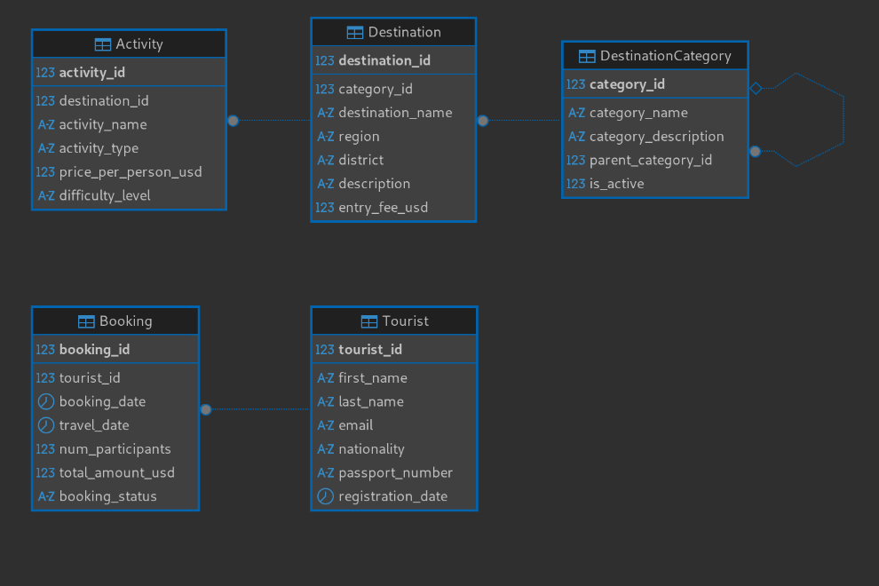
Implementations:

Database Creation and Setup
-- Drop and recreate database for clean setup
DROP DATABASE IF EXISTS Destination_Management;
CREATE DATABASE Destination_Management
CHARACTER SET utf8mb4
COLLATE utf8mb4_unicode_ci;

USE Destination_Management;

Table Definitions
DestinationCategory table.
CREATE TABLE DestinationCategory (
category_id INT NOT NULL AUTO_INCREMENT,
category_name VARCHAR(100) NOT NULL,
category_description TEXT NULL,
parent_category_id INT NULL,
is_active TINYINT(1) NOT NULL DEFAULT 1,
CONSTRAINT pk_category PRIMARY KEY (category_id),
CONSTRAINT uq_category_name UNIQUE (category_name),
CONSTRAINT fk_parent_cat FOREIGN KEY (parent_category_id)
REFERENCES DestinationCategory(category_id)
ON DELETE SET NULL ON UPDATE CASCADE
);

Destination table.

CREATE TABLE Destination (
destination_id INT NOT NULL AUTO_INCREMENT,
category_id INT NOT NULL,
destination_name VARCHAR(150) NOT NULL,
region VARCHAR(100) NOT NULL,
district VARCHAR(100) NOT NULL,
description TEXT NOT NULL,
entry_fee_usd DECIMAL(8,2) NOT NULL DEFAULT 0.00,
CONSTRAINT pk_destination PRIMARY KEY (destination_id),
CONSTRAINT fk_dest_cat FOREIGN KEY (category_id)
REFERENCES DestinationCategory(category_id)
ON DELETE RESTRICT ON UPDATE CASCADE,
CONSTRAINT chk_entry_fee CHECK (entry_fee_usd >= 0)
);

Activity table.

CREATE TABLE Activity (
activity_id INT NOT NULL AUTO_INCREMENT,
destination_id INT NOT NULL,
activity_name VARCHAR(150) NOT NULL,
activity_type ENUM('Wildlife', 'Adventure', 'Cultural', 'Water', 'Scenic') NOT NULL,
price_per_person_usd DECIMAL(8,2) NOT NULL,
difficulty_level ENUM('Easy', 'Moderate', 'Challenging', 'Extreme') NOT NULL,
CONSTRAINT pk_activity PRIMARY KEY (activity_id),
CONSTRAINT fk_act_dest FOREIGN KEY (destination_id)
REFERENCES Destination(destination_id)
ON DELETE CASCADE ON UPDATE CASCADE
);

Tourist table

CREATE TABLE Tourist (
tourist_id INT NOT NULL AUTO_INCREMENT,
first_name VARCHAR(80) NOT NULL,
last_name VARCHAR(80) NOT NULL,
email VARCHAR(150) NOT NULL,
nationality VARCHAR(80) NOT NULL,
passport_number VARCHAR(40) NULL,
registration_date DATE NOT NULL DEFAULT (CURRENT_DATE),
CONSTRAINT pk_tourist PRIMARY KEY (tourist_id),
CONSTRAINT uq_tourist_email UNIQUE (email),
CONSTRAINT uq_passport UNIQUE (passport_number)
);

Booking table
CREATE TABLE Booking (
booking_id INT NOT NULL AUTO_INCREMENT,
tourist_id INT NOT NULL,
booking_date DATE NOT NULL DEFAULT (CURRENT_DATE),
travel_date DATE NOT NULL,
num_participants INT NOT NULL DEFAULT 1,
total_amount_usd DECIMAL(10,2) NOT NULL,
booking_status ENUM('Pending', 'Confirmed', 'Cancelled', 'Completed') NOT NULL DEFAULT 'Pending',
CONSTRAINT pk_booking PRIMARY KEY (booking_id),
CONSTRAINT fk_book_tourist FOREIGN KEY (tourist_id)
REFERENCES Tourist(tourist_id)
ON DELETE RESTRICT ON UPDATE CASCADE,
CONSTRAINT chk_travel_date CHECK (travel_date >= booking_date),
CONSTRAINT chk_participants CHECK (num_participants > 0)
);

Inserting the values into tables
DestinationCategory

INSERT INTO DestinationCategory (category_name, category_description) VALUES
('National Parks', 'Protected wildlife areas managed by UWA'),
('Lakes & Wetlands', 'Freshwater lakes, rivers, and wetland sites'),
('Urban & Cultural', 'City tours, heritage sites, cultural experiences');

INSERT INTO DestinationCategory (category_name, parent_category_id) VALUES
('Savanna Parks', 1),
('Forest Reserves', 1),
('Great Lakes', 2);

Destination

INSERT INTO Destination (destination_name, region, district, category_id, entry_fee_usd, description) VALUES
('Murchison Falls NP', 'Northern', 'Nwoya', 4, 40.00, 'Home to the world\'s most powerful waterfall.'),
('Bwindi Impenetrable NP', 'Western', 'Kanungu', 5, 50.00, 'A UNESCO site famous for gorilla trekking.'),
('Lake Bunyonyi', 'Western', 'Kabale', 6, 5.00, 'A beautiful freshwater lake with 29 islands.'),
('Kampala City Tour', 'Central', 'Kampala', 3, 0.00, 'A cultural journey through the capital city.');

Activity
INSERT INTO Activity (destination_id, activity_name, activity_type, price_per_person_usd, difficulty_level) VALUES
(1, 'Game Drive Safari', 'Wildlife', 45.00, 'Easy'),
(1, 'Nile Boat Cruise', 'Water', 30.00, 'Easy'),
(2, 'Gorilla Trekking', 'Wildlife', 700.00, 'Challenging'),
(4, 'Heritage City Walk', 'Cultural', 25.00, 'Easy');

Tourist
INSERT INTO Tourist (first_name, last_name, email, nationality, passport_number) VALUES
('John', 'Smith', 'john.smith@example.com', 'British', 'BK123456'),
('Amina', 'Nakato', 'amina.n@example.ug', 'Ugandan', 'UA987654');

Booking
INSERT INTO Booking (tourist_id, travel_date, num_participants, total_amount_usd, booking_status) VALUES
(1, '2026-06-01', 2, 150.00, 'Confirmed'),
(2, '2026-07-15', 1, 700.00, 'Pending');

Sample Data

Categories
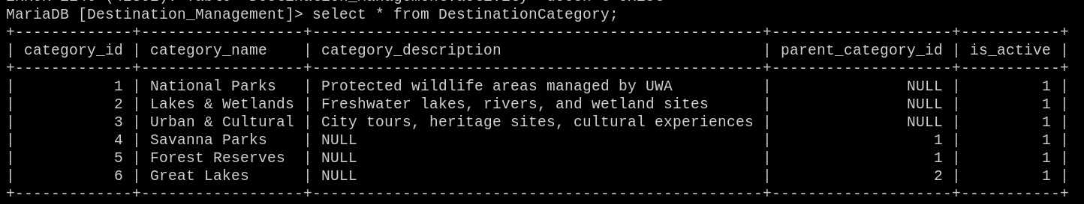

Destinations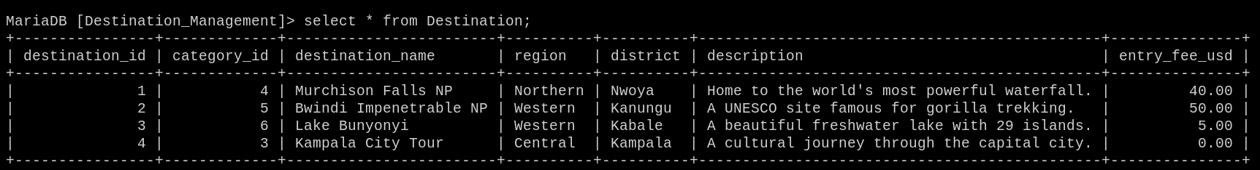

Tourist
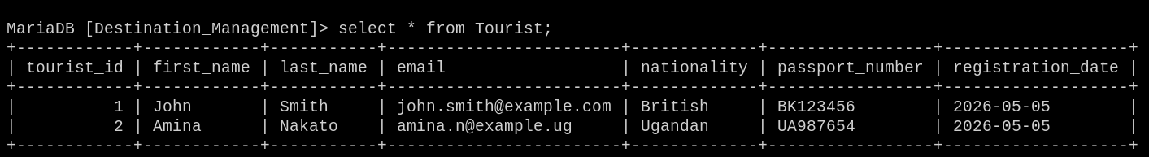

Activity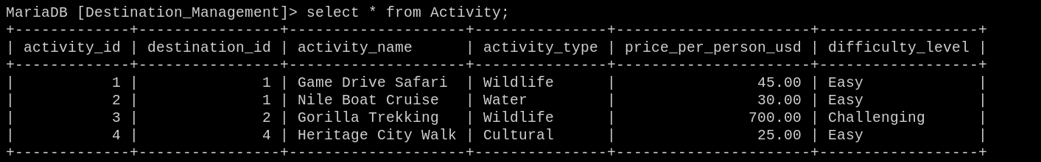

Booking
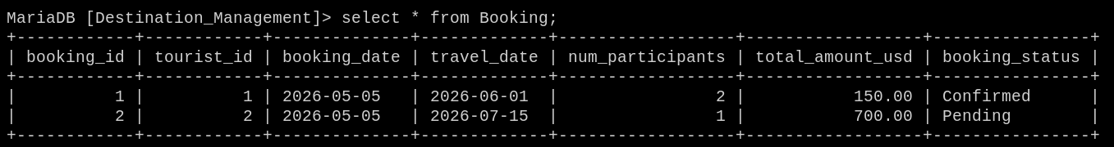

Sample queries and results
1.
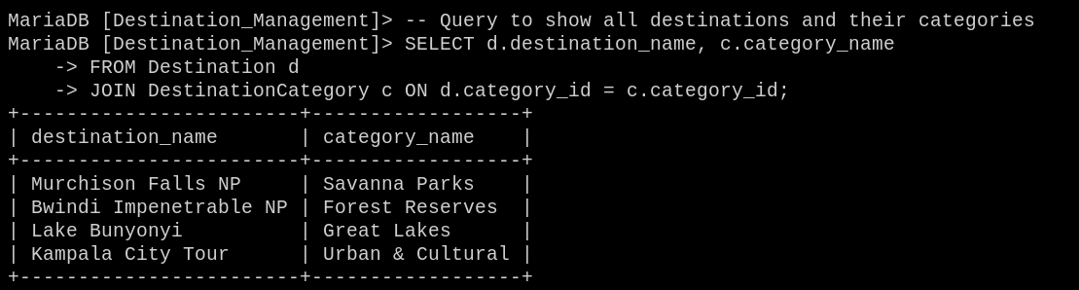

2.
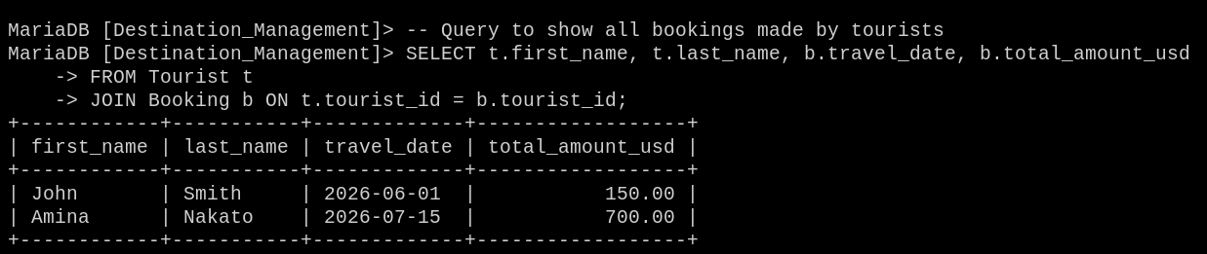

Integration Points with Other Modules
The Destination Module is designed as a self-contained, loosely-coupled sub-system. The following fields serve as integration anchors for other group members in the tourism sector;

Field | Table | Links To | Purpose
tourist_id | Tourist | Hotel, Transport, Payments Modules | Shared identity key across all modules
booking_id | Booking | Payments Module | Booking reference for payment invoices

Bibliography
• Connolly, T. & Begg, C. (2015). Database Systems: A Practical Approach to Design, Implementation
and Management (6th ed.). Pearson Education.
• Ramakrishnan, R. & Gehrke, J. (2003). Database Management Systems (3rd ed.). McGraw-Hill.
• Oracle Corporation (2023). MySQL 8.0 Reference Manual. Retrieved from
https://dev.mysql.com/doc/refman/8.0/en/
• Uganda Wildlife Authority (2024). Uganda National Parks & Tourism Statistics. UWA Official
Website. https://www.ugandawildlife.org
• Uganda Tourism Board (2023). Tourism Sector Annual Performance Report 2022/2023. UTB,
Kampala.
• Date, C.J. (2004). An Introduction to Database Systems (8th ed.). Addison-Wesley.
• Silberschatz, A., Korth, H.F. & Sudarshan, S. (2020). Database System Concepts (7th ed.).
McGraw-Hill.

